DIGITAL VIDEO STREAMING

DASAR MULTIMEDIA

Dosen Pengampu : A. Ais Prayogi Alimuddin, S.T., M.Eng.



Disusun Oleh:

Kelompok 1:

Ady Ulil Amri, D121231080, Kelas B

Farid Wajdi, D121231032, Kelas B

Ahmad Fiqri Nawwaf, D121231107, Kelas B

Platform:

Youtube & Netflix

DEPARTEMEN TEKNIK INFORMATIKA

FAKULTAS TEKNIK UNIVERSITAS HASANUDDIN

2024

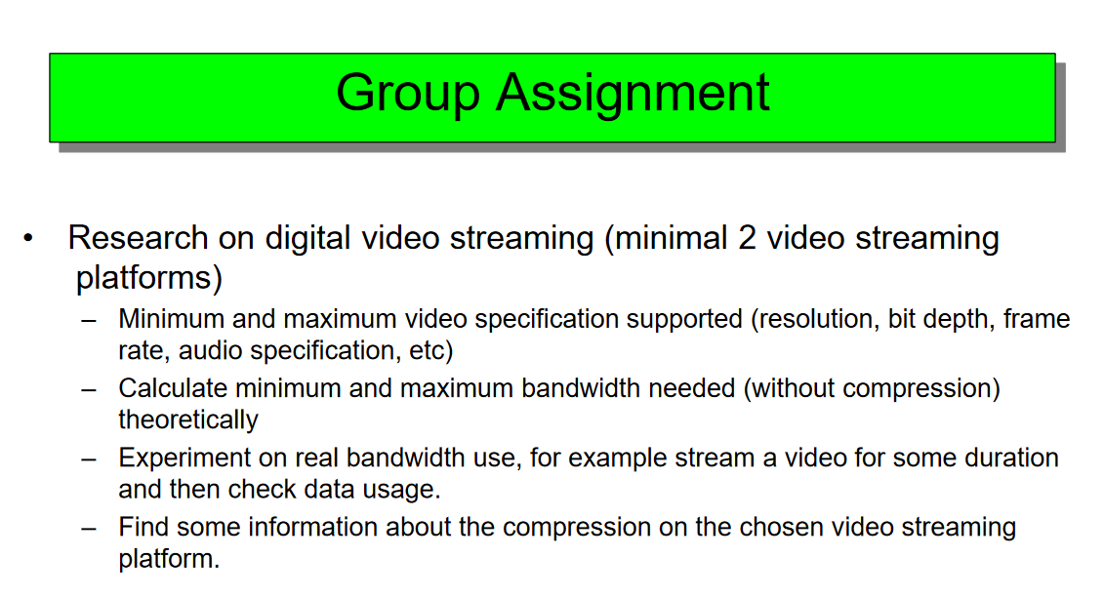

**Answer**

1. Minimum and maximum video specification supported (resolution, bit depth, frame rate, audio specification, etc)

**YouTube**

1. **Resolution**

Minimum = 144p Maximum = 8K (4320p)

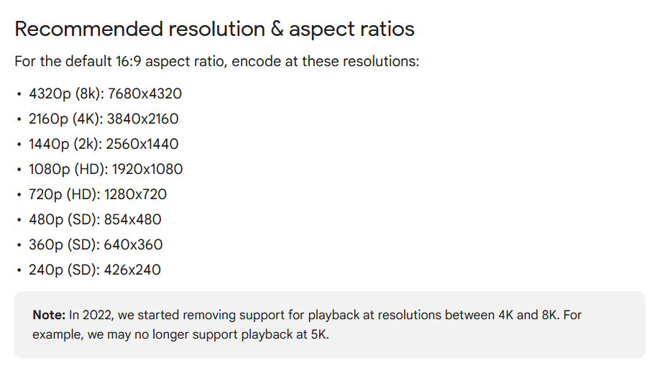

1. **Bit Depth**

Standar: 8-bit

HDR: 10-bit

1. **Frame Rate**

Standard = 24 fps sd. 30fps. Maximum = 60fps

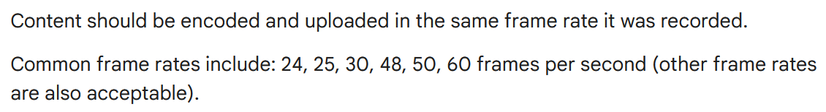

1. **Audio Specification**

Channels: Stereo or Stereo + 5.1

Sample rate 96khz or 48khz

**Netflix**

1. **Resolution**

****Minimum = 144p Maximum = 8K (4320p)

1. **Bit Depth**

Standar: 8-bit HDR: 10-bit

1. **Frame rate**

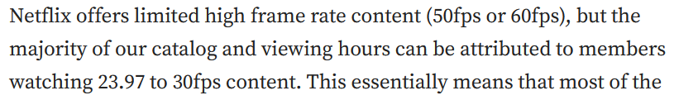

1. **Audio Specification**

5.1 surround sound, 2.0 stereo (jika 5.1 tidak tersedia), dan mono



1. Calculate minimum dan maximum bandwidth needed (without compression) theoretically

Bandwidth (bps) = Resolution width × Resolution height × Frame rate × Bit depth × 3

**YouTube**

**Minimum (144p, 24 fps, 8-bit)**

Resolution: 256 x 144

Frame Rate: 24 fps

Bit Depth: 8-bit

Bandwidth = 256×144×24×8×3

= 212,336,640 bps

= 0.212 Mbps

**Maximum (8K, 60 fps, 10-bit)** Resolution: 7680 x 4320 Frame Rate: 60 fps

Bit Depth: 10-bit

Bandwidth = 7680×4320×60×10×3

= 59,719,680,000 bps

= 59.72 Gbps

**Netflix**

**Minimum (480p, 24 fps, 8-bit)**

Resolution: 640 x 480

Frame Rate: 24 fps

Bit Depth: 8-bit

Bandwidth = 640×480×24×8×3

= 1,768,857,600 bps

=1.77 Mbps

**Maximum (4K, 60 fps, 10-bit)**

Resolution: 3840 x 2160

Frame Rate: 60 fps

Bit Depth: 10-bit

Bandwidth = 3840×2160×60×10×3

= 14,929,920,000 bps

= 14.93 Gbps

1. Experiment on real bandwidth use, for example stream a video for some duration and then check data usage.
   1. **Youtube** (**1440p**, 3:32 Menit, 24 fps, **Data Usage** 138 MB):
      1. **Durasi video dalam detik** : 3 Menit x 60 detik = 180 + 32 = 212 s
      2. **Bitrate** : $\frac{Data Usage}{Duration}=\frac{138 MB x 8 bits}{192 s}≈5.2075 Mbps$
   2. **Netflix Mobile** (**Auto Resolution**, 23:38 Menit, 24 fps, **Data Usage** 172 MB):

The Netflix app selects a setting that balances data usage and video quality.

* + 1. **Durasi video dalam detik** : 23 Menit x 60 detik = 1380 + 38 = 1418 s
    2. **Bitrate** : $\frac{Data Usage}{Duration}=\frac{172 MB x 8 bits}{1418 s}≈0.9704 Mbps$

1. Find some information about the compression on the chosen video streaming platform.
   1. **YouTube** uses three main codecs: H.264, VP9, and AV1.
      1. H.264: Standard codec for low to mid-range quality and viewership.
      2. VP9: Utilized for higher resolutions and more popular videos.
      3. AV1: Advanced codec used for very high view counts and resolutions, offering better compression efficiency.
   2. **Netflix**
      1. **H.264/AVC Main Profile (AVCMain)**
         * A widely-used video compression format supported on many devices, including web browsers, TVs, and mobile devices.
      2. **H.264 High Profile (AVCHi-Mobile)**
         * This codec is more compression-efficient than the baseline and main profiles but requires greater decoding capabilities.
      3. **VP9 (Profile 0)**
         * This codec has broad decoder support on Android OS and offers better codec efficiency on mobile devices.
      4. **HEVC (High Efficiency Video Coding)**
         * Used for streaming video in 4K HDR on some TVs.
      5. **AV1**
         * This codec is reportedly 20–40% more efficient than HEVC, offering higher video quality at any given bitrate. Netflix began delivering AV1 to compatible Android devices in 2020 and has since expanded its use for 4K streams.

**Referensi**

<https://support.google.com/youtube/answer/6375112?hl=en&co=GENIE.Platform%3DDesktop&oco=1>

<https://support.google.com/youtube/answer/1722171?hl=en#zippy=%2Ccontainer-mp%2Caudio-codec-aac-lc%2Cvideo-codec-h%2Cbitrate%2Cframe-rate>

<https://help.netflix.com/en/node/13444>

<https://partnerhelp.netflixstudios.com/hc/en-us/articles/360001794307-Netflix-Sound-Mix-Specifications-Best-Practices-v1-5#h_01ESQ5ZG1Y7AEBJQQE4V7HBZBV>

<https://www.streamingmediaglobal.com/Articles/ReadArticle.aspx?ArticleID=156048#:~:text=And%20that's%20more%20or%20less,consoles%20and%20even%20on%20browsers>.

<https://streaminglearningcenter.com/codecs/which-codecs-does-youtube-use.html>